ORIGINAL ARTICLE

Knowledge, Attitudes and Practices among Women of Reproductive Age on Human Papillomavirus Infection, Cervical Cancer and Vaccination in Otukpo, Nigeria

Olajide Akinnibosun¹*, Onyukwo Grace Abakpa¹, Adole John Ujoh¹, Dominic Agbo Oche¹, Suleiman Zakari², Doowuese Yandev¹, Peter Adikwu¹, Onyemowo Okewu David¹, Oludare Agboola^{3,7}, Simon Paul³, Onyemocho Audu⁴, Emmanuel Odu⁵, Innocent Achanya O. Ujah⁶, Joseph Anejo-Okopi¹*

OPEN ACCESS

Citation: Olajide Akinnibosun, Onyukwo Grace Abakpa, Adole John Ujoh, et al., Knowledge, Attitudes and Practices among Women of Reproductive Age on Human Papillomavirus Infection, Cervical Cancer and Vaccination in Otukpo, Nigeria. Ethiop J Health Sci. 2024; 34(1):15. doi: http://dx.doi.org/ 10.4314/ejhs. v34i1.3
Received: May 3, 2023
Accepted: December 15, 2023
Published: January 1, 2024
Copyright: © 2024 Olajide A, et al. This is an open access article distributed under the terms of the Creative Commons Attribution License, which permits unrestricted use, distribution, and reproduction in any medium, provided the original author and source are credited.
Funding: Nil.
Competing Interests: The authors declare that this manuscript was approved by all authors in its form and that no competing interest exists.
Affiliation and Correspondence:
¹Department of Microbiology, Federal University of Health Sciences, Nigeria
²Department of Biochemistry, Federal University of Health Sciences, Nigeria
³Department of Biological Sciences, Federal University of Health Sciences, Nigeria
⁴Department of Community Medicine, College of Medicine, Federal University of Health Sciences, Nigeria
⁵Institute of Global Health and Health Security, Federal University of Health Sciences, Nigeria
⁶Office of the Vice-Chancellor, Federal University of Health Sciences, Nigeria
⁷UNESCO International Centre for Biotechnology, University of Nigeria, Nigeria
*Email: olajideakinnib@gmail.com; josephokopi@yahoo.com

ABSTRACT

BACKGROUND: Knowledge, attitudes and practices (KAP) of human papilloma virus (HPV) is a necessary measure in curtailing delayed diagnosis and poor control practices. The objective of this study was to assess the knowledge, attitudes and practices vis-à-vis HPV infection, cervical cancer and vaccination among women.
METHODS: This cross-sectional study was conducted at 15 selected health-care facilities in Otukpo metropolis and it involved 168 pregnant women. The data were collected using structured questionnaire, and analysed for descriptive and analytical statistics using Epi Data Version 3.1 and SPSS statistical package Version 21.
RESULTS: Most of the respondents (75.0%) have heard of human papilloma virus and their information source were mostly the health-care providers. In total, 132(78.6%) agreed to take the vaccine if offered for free but 152(90.5%) stated that it is imperative to seek the opinion of health providers before vaccine uptake. However, only 27(16.1%) have undergone recommended checkup for human papilloma virus/cervical cancer and 23(13.7%) have taken at least a vaccine dose. Some respondents 66(39.3%) had good knowledge while 95(56.6%) demonstrated positive attitude. However, most respondents 161(95.8%) demonstrated poor practices.
CONCLUSIONS: There is enormous need to improve HPV sensitization especially in women due to cervical cancer associated risks. Healthcare personnel are therefore encouraged to create more awareness on HPV infection and screening of cervical cancer (CC) via counseling sessions and communications tool like the new media. KAP approach is a critical tool towards successful CC screening and HPV control.
KEYWORDS: Human papillomavirus, Attitudes, Practices, Reproductive age, Vaccination, Otukpo, Nigeria

INTRODUCTION

Human papilloma virus (HPV) is a viral infection of global importance and a prevalence that varies widely across geographical regions. Notably, sub-Saharan Africa remains a region that is prominently threatened by HPV (1). HPV infection is mainly transmitted via sexual contact (2), and most sexually acquired cases of HPV usually occurred shortly after becoming sexually active (3). According to global reports, 75% of sexually active individuals got infected with HPV infection over their lifespan (4).
In many developing nations of the world, women especially those of parturition age face umpteen social and health challenges. In Nigeria, about 23.7% of women and 73% of men contract HPV genital infection within the first three years of sexual debut (5). HPV infection has been indicated to be pervasive among juvenile women of age 16-22 years (6). Most times, HPV infection can be transient, latent and unnoticed for a prolonged period due to the activities of antibodies (7). However, chronic high-risk HPV infection has been severally linked to the growth of precancerous cells which subsequently triggers the development of cervical cancer (CC) (2).
Globally, cervical cancer is the fourth most common cancer in women with about 604,000 new cases and 342,000 deaths in 2020, and about 90% of the new cases and deaths in 2020 occurred in low- and middle-income countries (8). In Nigeria, cervical cancer ranks as the second most common cancer in women aged 15-44 years with about 14,943 new cases diagnosed annually (5). HPV cases are expected to intensify to about 9.9 million with 5.5 million deaths annually by 2030 as the world population increases (9).
Vaccination, cytological examination and health sensitization represent the main strategies for HPV prevention and control (10). These control strategies against cervical cancer are enhanced by early detection of HPV and the treatment of pre-cancerous lesions. The HPV vaccine has also been recommended by WHO as the fundamental approach for the prevention of cervical cancer, and should ideally be administered preceding first sexual contact (11). Although the vaccines have been approved for administration in Nigeria since 2009, it is mostly accessible to privileged individuals that can afford the cost (11). This contributed to the major challenges limiting HPV vaccination exercise in Sub-Saharan Africa which is the non-release of funds by government agencies to sponsor free vaccination and the inability of low-earners to self-sponsor (12-14). Presently in Nigeria, HPV vaccines are mostly available in private health facilities and at unreadily affordable rates. Despite the impending danger this could result into, the efforts being made by the Nigerian government to incorporate HPV vaccine into the national basic immunization programme remain rather slow (3). However, several African countries have started having access to HPV vaccine through the assistance of Global Alliance for Vaccines and Immunization (GAVI) and Nigeria is currently in the pre-introduction era of the vaccine uptake among adolescent females (15,16).
Nevertheless, the understanding of the implications of HPV infection and responses towards public acceptability of the vaccine have been low as several individuals demonstrated hesitation on getting administered even when free (13,16). Vaccine safety is a major concern expressed by the individuals who were reluctant to accept the vaccination of especially in teenage females (17). This study aimed to assess the knowledge, attitudes, and practices of HPV infection among women of reproductive age as it relates to vaccination and cervical cancer awareness in Otukpo, Benue State, Nigeria.

MATERIALS AND METHODS

Study design: The descriptive cross-sectional study was conducted in fifteen health facilities in Otukpo Township. Otukpo local government area has an estimated population of 266,411 in which 129,799 is females (18). The study was conducted between November and December 2021 using structured questionnaire which was adapted in accordance with previous literatures (19-20). The variables analyzed include socio-demographic information, knowledge of HPV, attitude and practice towards HPV.

Sample size: This study involved 168 women that were selected for the study from the 15 health facilities that provides maternity care services in Otukpo metropolis based on the population of women registered for antenatal checkup during the study period. The inclusion criteria include consenting pregnant women visiting the health facilities for antenatal check-up at the time of conducting the research. Participants that declined consent were excluded. The sample size (n) was calculated using the Taro-Yamane formula n= () at 95% confidence interval as previously described (21). Where N= Total population under study and e= 5% minimal error. Based on the health facilities’ records, the total population of women registered for antenatal checkup during the study period was 284, which connoted the sample size to be a minimum of 166 participants.
Sampling procedure and data collection: Structured questionnaire adapted from a previous study was administered for data collection. Information was obtained from the respondents using structured questionnaire adapted from previous studies (19-20). The questionnaires were written in English language and interpreted in local dialects upon request. The questionnaire included the respondents’ socio-demographic characteristics, and their perspectives as regards the knowledge, attitude and practice of human papilloma virus infection, mode of transmission, signs and symptoms, treatment and preventive measures. The composite measure of respondents’ knowledge, attitude and practice was measured using a scoring system where values were assigned to positive response in knowledge, attitude or practice section, while zero score was awarded for a negative response. Positive response of 80% and above was considered good, positive response greater than 50% but less than 80% was considered fair and positive response of 50% or less was classified as poor. In knowledge, 9-11 (≥80%) positive response was considered as good, 6-11 (50%-79%) was considered as fair while ≤5 (≤50%) was classified as poor knowledge. In attitude, 6-7 (≥80%) positive response was considered as good, 4-5 (50%-79%) was considered as fair while ≤3 (≤50%) was classified as poor knowledge. In practice, 4-5 (≥80%) positive response was considered as good, 3 (50%-79%) was considered as fair while ≤2 (≤50%) was classified as poor knowledge.

Statistical analysis: The data was analyzed using Epi Data Version 3.1 and SPSS statistical package Version 21. Descriptive statistics and cross tabulations were used to explore statistical relationships between the study population and relevant variables. Multivariate logistic regression models were used in determining factors associated with the dependent variables and independent variables. Odds ratio was determined using 95% Confidence Intervals (95% CI). Chi square test was used to explore proportional relationship between groups. The level of statistical significance was at p < 0.05 (providing 95% confidence interval).
Ethics: The research protocol was designed according to the guidelines recommended for biomedical researcher involving Human Subjects and the ethical standards of the declaration of Helsinki and reviewed by the Health Research Ethics Committee of Federal University of Health Sciences, Otukpo. The research protocols was approved by the Health Research Ethics Committee (HREC) General Hospital, Otukpo, Benue State with Reference no: GHOB/HREC/26-10-2021-006 as it pose low and negligible risks to participants. The respondents were acquainted with adequate information regarding the study before the interviews were conducted and confidentiality of the respondents was ensured. Informed consent was obtained from all participants as regards this study. The management of hospitals and health facilities gave permission to prior to data collection.
RESULTS

Socio-demographic characteristics among women of reproductive age towards HPV: A total of 168 pregnant female participated in this study. The socio-demographic details of the participants showed that ages of the respondents ranged from 18 to 57 years with the mean age at 25.41 ± 7.26 years. Majority of the respondents 96(57.1%) has attained primary and/or secondary education, 94(56.0%) have no child yet while 81(48.2%) were primigravid.

Table 1: Distribution socio-demographic characteristics among women of reproductive age.
Characteristics | Frequency | Percentage (%)
Age (in years)
18 – 28 | 122 | 72.6
29 – 42 | 41 | 24.4
43 – 57 | 5 | 3.0
Habitat
Rural | 88 | 52.4
Urban | 80 | 47.6
Person living with
Alone | 28 | 17.7
Husband | 70 | 41.7
Boyfriend | 3 | 1.8
Friends | 7 | 4.2
Relatives | 60 | 35.7
Level of education
No formal education | 0 | 0
Primary | 3 | 1.8
Secondary | 93 | 55.4
Higher education | 72 | 42.9
Religion
Christian | 158 | 94.0
Muslim | 10 | 6.0
Marital status
Single | 89 | 53.0
Married | 79 | 47.0
Occupation status
Self employed | 90 | 53.6
Govt. employed | 18 | 10.7
Unemployed | 60 | 35.7
Previous history of pregnancy
None | 81 | 48.2
1 – 4 | 68 | 40.5
5 – 8 | 18 | 10.7
9 – 11 | 1 | 0.6

Knowledge of human papilloma virus among women of reproductive age: Most of the respondents 126(75.0%) have previously heard of human papilloma virus and the main source of their information was healthcare providers (74.6%). However, only 105(62.5%) were aware that HPV can be transmitted sexually. A total of 85(50.6%) were aware that HPV could cause cervical cancer while 119(70.8%) affirmed that HPV vaccine could protect them from getting infected.

Table 2: The knowledge of human papilloma virus among women of reproductive age.
Knowledge items | Response | Frequency | Percent
Have you heard of human papilloma virus? | Yes | 126 | 75.0
 | No | 42 | 25.0
If Yes, what is your source of information? | Radio/TV | 29 | 23.0
 | Healthcare provider | 94 | 74.6
What causes HPV infection? | Virus | 111 | 66.0
 | Bacteria | 20 | 11.9
 | Fungi | 5 | 3.0
 | I don’t know | 32 | 19.1
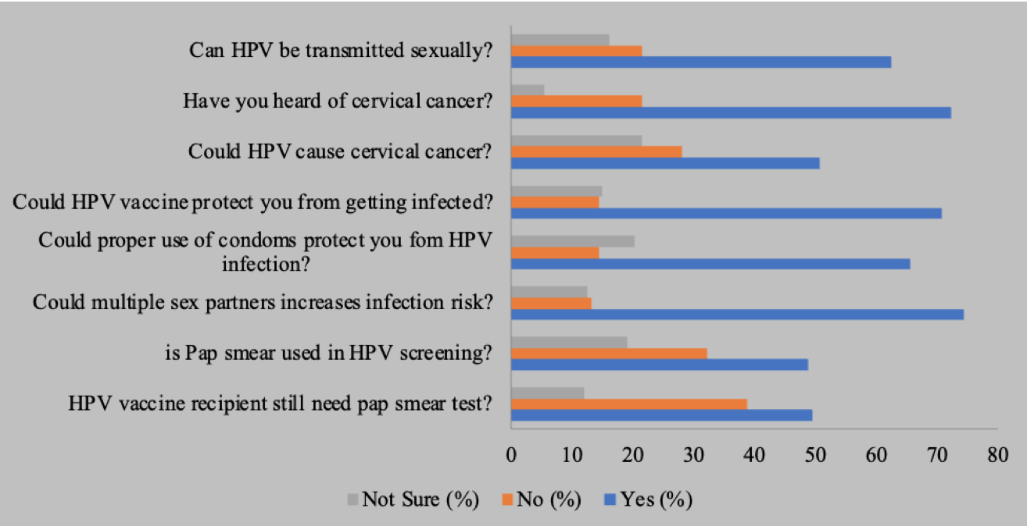
Figure 1: Human papilloma virus knowledge among women of reproductive age.

Attitude of women of reproductive age to the human papilloma virus infection: With regard to the respondents’ attitudes to HPV, 108(64.3%) agreed that HPV could trigger other health complications. In total, 132(78.6%) agreed to take the vaccine if offered for free and 152(90.5%) stated that it is compulsory to seek the opinion of health providers before taking the HPV vaccine.

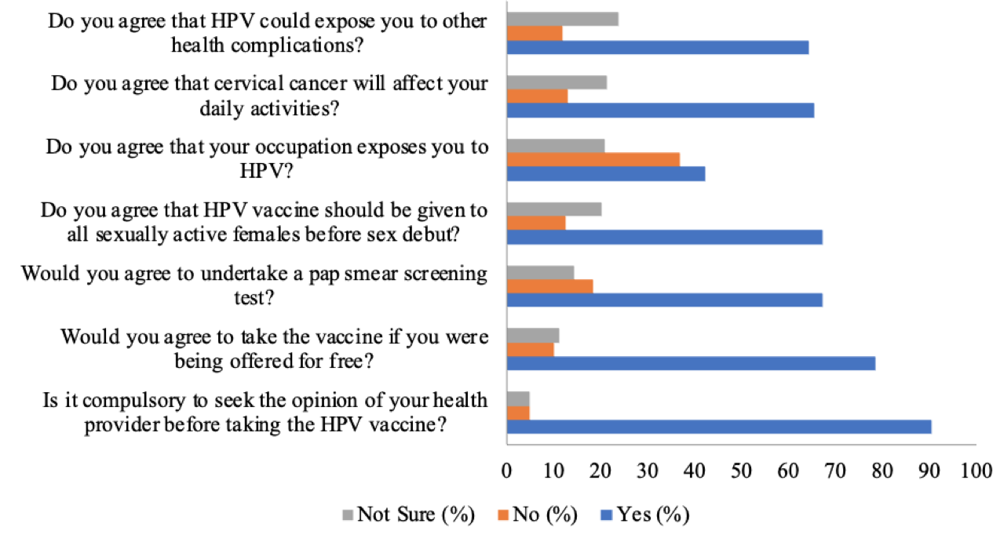Figure 2: The attitude of women of reproductive age towards human papilloma virus.

Preventive practice of women of reproductive age to the human papilloma virus infection: In terms of preventive approaches among the respondents, only 27(16.1%) have undergone recommended checkup for human papilloma virus/cervical cancer while 23(13.7%) have taken a preventive dose of the HPV vaccine. In total, 66(39.3%) affirmed that they use condoms during sex as singles.

EMBED Excel.Chart.8 \s 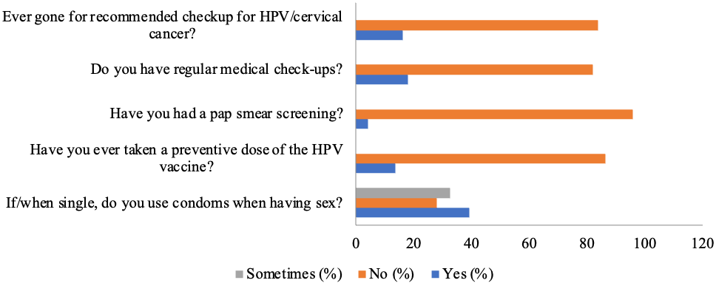Figure 3: The preventive practice of women of reproductive age towards human papilloma virus.

Relationship of factors associated with knowledge, attitude and practice towards HPV: Using multivariate logistic regression, it was observed that age group (18-28) was 0.231 times likely to be knowledgeable on HPV infection than other age groups. Additionally it was observed that age group (18-28) was 0.925 times more likely to be exhibit good attitude towards the prevention of HPV compared to age group (29-30) while age group (18-28) were 0.436 likely to demonstrate better attitude towards HPV infection compared to other age groups. Although some of the respondents having good knowledge and attitude to HPV, most of them demonstrated very poor practice. The effect of the variables lacks significant association with knowledge, attitude and practices as the p-value were greater than 0.05, with few exceptions based on the number of children and pregnancy history.

Table 3: Relationship of factors associated with knowledge, attitude and practice towards HPV.

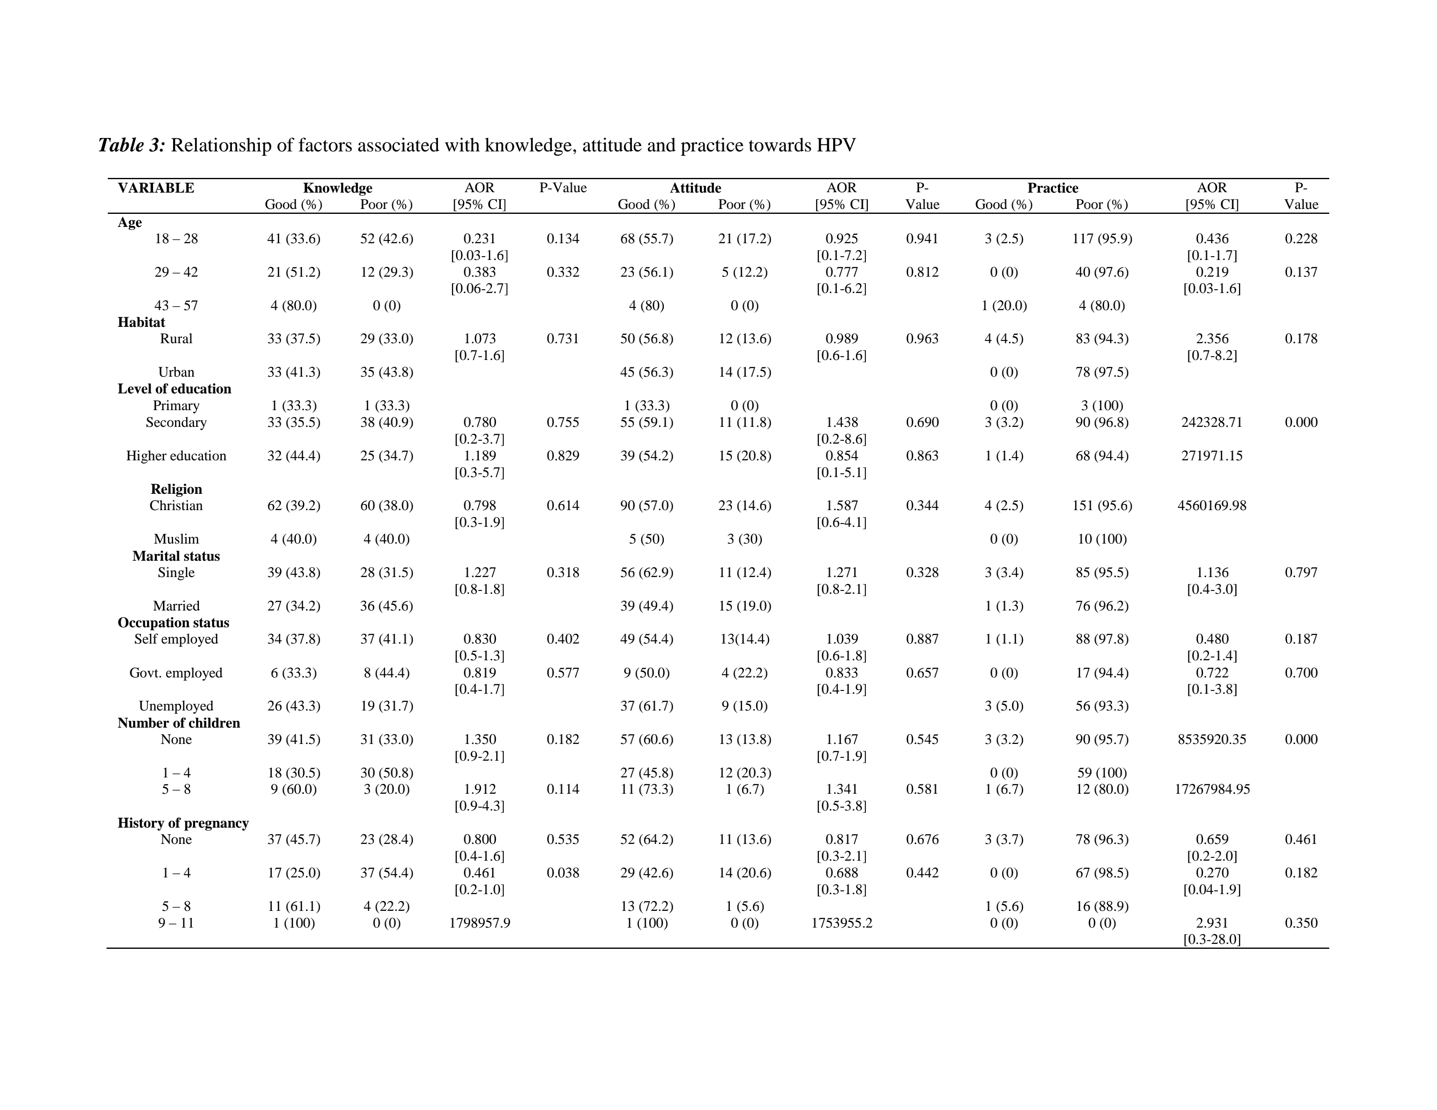

DISCUSSION
Improved knowledge, attitudes and practices in respect to HPV infection and screening are practical approaches in mitigating the burden of cervical cancer among women. This study was conducted to assess the knowledge of women of reproductive age in Otukpo about the human papillomavirus.
Majority of the respondents (75.0%) have heard of human papilloma virus. This is relatively high and consistent with the 83.8% and 63.3% reported by comparable maternity clinic-based studies in Nigeria (22) and Russia (23) respectively. However, school-based survey on females reported lower awareness level of 30% in Nigeria (24) and 43.2% in South Africa (25). The disparity in awareness between maternity clinic-based and school-based studies could be attributed to public perspectives that adolescents and young female respondents in school-based studies are not matured enough for discussions relating to sexual activity as reported in previous studies (26,27). A study on primigravid antenatal clinic attendees earlier reported that only 5.4% of the respondents have heard of HPV on their first antenatal visit (28). Higher level of awareness in maternity/clinic-based studies further attest to the influence healthcare workers exert on disease awareness and general health information management. Profound public conviction conferred on health care workers as reliable sources of health information has been previously reported (29,30).
In this study, majority of the participants (62.5%) were aware that HPV can be transmitted via sex. Higher level of awareness 87.0% that HPV can be transmitted via sexual intercourse have been reported in comparable clinic-based study in Nigeria (19). Contrarily, very low level of awareness (0.9%) regarding the sexual transmission of HPV has been reported among adolescent school children in Nigeria (24). Most of the respondents (60.7%) in this study considered the use of condom a practice that is not mandatory in the prevention of HPV. In disagreement to this, frequent use of condoms has been notably associated with dwindling rates of sexually transmitted infections including HPV infection (31).
Among the respondents, 50.6% were aware that HPV could cause cervical cancer while 70.8% affirmed that HPV vaccine could prevent infection. Contrarily, our finding is significantly higher than the 8.8% and 29.5% reportedly aware that HPV could cause cervical cancer in previous studies among women of reproductive age in Ethiopia and Nigeria respectively (20,32). Inadequate awareness on cervical cancer has been reported even in high-income nation (26). This implies that the low awareness on cervical cancer is a global situation especially among adolescents and young adults. Low level of awareness on HPV and its correlation with cervical cancer is a major factor behind the unwavering burden of cervical cancer and other HPV related diseases (32).
In this study, most of the respondents (67.3%) positively responded that all sexually active females should be given the HPV vaccine before sex debut. In Nigeria, the relatively expensive nature of the vaccine adversely affects its uptake (19), despite its recommendation by the Nigerian federal ministry of health (33). However, parent and guardian are usually reluctant on early vaccination and discussions on sexually related infections with the younger age groups because it may give them impressions that they are now matured enough to get involved in sexual activities (27,34). Most of the respondents (90.5%) in this study emphasized that it is compulsory to seek information from health practitioners before taking HPV vaccine while some stated that they would refuse taking the vaccine even when offered for free. This also agrees with the reports of studies among women in Europe and America that reasons for the unwillingness in getting vaccinated include concerns of vaccine safety and the demand for health workers opinion other than financial costs (26,35).
The knowledge and practice of Pap smear test from this study was relatively poor as more than half of the respondents do understand its relationship with the detection of HPV infections and only 4.2% of the total respondents have taken the test. This was similarly reported in other study conducted in Nigeria (36) but better awareness as regards Pap smear have been reported in study conducted in Greece (37). The variance in level of awareness, practice and acceptability of cervical screening could be due to factors such as illiteracy, ignorance and inconsistent cervical cancer screening programs among regions (38).
In this study, it was observed that age group [29-42] was 0.383 times likely to have more knowledgeable about HPV infection than [18-28] age group. Previous study has encouraged women at all ages to seek information and regularly get screened for HPV related infection including cervical cancer (39). Furthermore, it was observed in this study that participants that have attained higher education were more likely to have more knowledge on HPV related infections than those that haven’t. This is an indication that educated women generally have more access to information on HPV infection and its vaccination as previously reported in a study among women in Nigeria (40). Also, it has been reported that women with higher education and those with children were more likely to be knowledgeable about HPV in comparison to women with lower educational and the nonparturitive women in a maternity clinic-based study in Russia (23). However, the respondents that demonstrated good knowledge and attitude towards HPV observably demonstrated very poor practice. This agrees with the findings from previous study among women in a clinic-based survey in Nigeria that although better education is a prominent tool in health promotion, it isn’t the sole determinant of better health practices (39). Therefore, as educational efforts to improve the knowledge on HPV is on the increase, there are need to further inform the people and health workers on the importance of improved practice as it is a major tool towards HPV prevention.
In conclusion, the findings of this study highlight the need to improve the knowledge of HPV among younger age groups and regular screening among pregnant women. HPV vaccination has a relatively low coverage in Nigeria and the low awareness of HPV vaccine revealed in this study further emphasize on the need to improve HPV awareness and acceptability by including the vaccine in the national immunization routine schedule. HPV infection remains critical to reproductive women and they need to be properly informed about the merits of vaccination and the health threats associated with not receiving the vaccine. This is due to the fact that poor understanding as regards the dangers of HPV and its consequences could result in permanent health difficulties including cervical cancer. Therefore, intense health campaign on HPV and HPV vaccine among women of reproductive age is notably recommended.

ACKNOWLEDGEMENTS
The authors acknowledge the Board of Trustees of Hospitals’ Owners in Otukpo metropolis for their permission and support. We also thank the respondents who participated in the study.

REFERENCES
- Black E, Richmond R. Prevention of cervical cancer in Sub-Saharan Africa: the advantages and challenges of HPV vaccination. Vaccines. 2018; 6(3): 61.
- Galvao MPSP, Araujo T, Rocha SS. Knowledge, attitudes, and practices of adolescents regarding human papillomavirus. Rev Saude Publica. 2022; 56:12.
- Isara AR, Osayi N. Knowledge of human papillomavirus and uptake of its vaccine among female undergraduate students of Ambrose Alli University, Ekpoma, Nigeria. J Community Med Prim Health Care. 2021; 33(1): 64-75.
- World Health Organization. Fact sheet on human papillomavirus (HPV) and cervical cancer. 2019. https://www.who.int/news-room/fact-sheets/detail/human-papillomavirus-(hpv)-and-cervical-cancer.
- Bruni L, Albero G, Serrano B, et al. ICO/IARC Information Centre on HPV and Cancer (HPV Information Centre). Human Papillomavirus and related diseases in Nigeria. Summary Report. 2019. https://www.hpvcentre.net/statistics/reports/XWX.pdf.

- Mbulawa ZZ, Van Schalkwyk C, Hu N-C, et al. High human papillomavirus (HPV) prevalence in South African adolescents and young women encourages expanded HPV vaccination campaigns. PLoS One. 2018; 13(1): e0190166.
- Shew ML, Ermel AC, Tong Y, Tu W, Qadadri B, Brown DR. Episodic detection of human papillomavirus within a longitudinal cohort of young women. J Med Virol. 2015; 87(12):2122–2129.
- Sung H, Ferlay J, Siegel RL, et al. Global cancer statistics 2020: GLOBOCAN estimates of incidence and mortality worldwide for 36 cancers in 185 countries. CA Cancer J Clin. 2021; 71:209–249.
- Dönmez S, Öztürk R, Kısa S, Weller BK, Zeyneloğlu S. Knowledge and perception of female nursing students about Human Papillomavirus (HPV), cervical cancer, and attitudes toward HPV vaccination. J Am Coll Health. 2019; 67(5): 410-417.
- Kops NL, Hohenberger GF, Bessel M, et al. Knowledge about HPV and vaccination among young adult men and women: results of a national survey. Papillomavirus Res. 2019; 7: 123-128.
- Ohareri B, Adefolaju AO, Onyeneho CA. Knowledge, attitudes and perceptions of Nigerian parents towards human papilloma virus (HPV) vaccines. Eur J Midwifery. 2020; 4: 2.
- Farmer P. The Second Life of Sickness: on structural violence and cultural humility. Human Organization 2016; 75: 279-288.
- Nguyen NY, Okeke E, Anglemyer A, et al. Identifying perceived barriers to human papillomavirus vaccination as a preventative strategy for Cervical cancer in Nigeria. Ann Glob Health. 2020; 86: 118.
- Global Alliance for vaccines and immunization (GAVI). https://www.gavi.org/types-support/vaccine-support/ human-papillomavirus, 2020. [Accessed 20 Nov 2023].

- Balogun FM, Omotade OO. Facilitators and barriers of healthcare workers’ recommendation of HPV vaccine for adolescents in Nigeria: views through the lens of theoretical domains framework. BMC Health Serv Res. 2022; 22: 824. doi: 10.1186/s12913-022-08224-7.
- Rabiu I, Yahuza Z. Knowledge and attitude towards human papilloma virus infection, vaccines and cervical cancer prevention among school students in Kano, Nigeria. Adv Virol. 2023: 2023: 2803420. doi: 10.1155/2023/2803420.
- Audu BM, Bukar M, Ibrahim AI, Swende TZ. Awareness and perception of human papilloma virus vaccine among healthcare professionals in Nigeria. J Obstet Gynaecol. 2014; 2014: 1-4.
- National Population Commission (NPC). Federal Republic of Nigeria 2006 population and Housing Census. Population distribution by sex, state, local government area and senatorial district. Priority table Volume (iii). 2010; pp. 35.
- Okunade KS, Sunmonu O, Osanyin GE, Oluwole AA. Knowledge and acceptability of human papillomavirus vaccination among women attending the gynaecological outpatient clinics of a university teaching hospital in Lagos, Nigeria. J Trop Med. 2017; 2017: 8586459.
- Aweke YH, Ayanto, SY, Ersado TL. Knowledge, attitude and practice for cervical cancer prevention and control among women of childbearing age in Hossana Town, Hadiya zone, Southern Ethiopia: community-based cross- sectional study. PLoS One. 2017; 12(7): e0181415.
- Tepping BJ. Elementary sampling theory, Taro Yamane. Englewood Cliffs, New Jersey: Prentice-Hall, Inc.; 1967. pp. x-405. J Am Stat Assoc. 1968; 63: 728-730.
- Odetola TD, Ekpo K. Nigerian women’s perceptions about human papilloma virus immunizations. J Communit Med Health Educ. 2012; 2: 191.

- Roik EE, Sharashova EE, Nieboer E, Kharkova OA, Postoev VA, Odland JO. Knowledge about human papillomavirus and prevention of cervical cancer among women of Arkhangelsk, Northwest Russia. PLoS One. 2017; 12(12): e0189534.
- Ezeanochie M, Olasimbo P. Awareness and uptake of human papilloma virus vaccines among female secondary school students in Benin City, Nigeria. Afr Health Sci. 2020; 20(1): 45-50.
- Mushasha MP, Mashau NS, Ramathuba DU. The knowledge of female students regarding the human papilloma virus and vaccines at a selected university in South Africa. Open Public Health J. 2021; 14: 257-263.
- Patel DA, Zochowski M, Peterman S, Dempsey AF, Ernst S, Dalton VK. Human papillomavirus vaccine intent and uptake among female college students. J Am Coll Health. 2012; 60(2): 151-161.
- Ojule IN, Anika IE. Human Papilloma Virus Transmission: Knowledge and Uptake of HPV Vaccine among In-school Adolescent Girls in South-South Nigeria. Int J Trop Dis Health. 2020; 41(8): 25-37.
- de Silva AHW, Samarawickrema N, Kasturiratne A, Skinner SR, Wickremasinghe AR, Garland SM. Awareness of human papillomavirus, cervical cancer and its prevention among primigravid antenatal clinic attendees in a tertiary care hospital in Sri Lanka: a cross-sectional study. Sex Health. 2019; 16(3): 212-217.
- Domgue JF, Chido-Amajuoyi OG, Yu RK, Shete S. Beliefs about HPV vaccine’s success at cervical cancer prevention among adult US women. JNCI Cancer Spectr. 2019; 08 27;3(4
- Tesfaye ZT, Bhagavathula AS, Gebreyohannes EA, Tegegn HG. Knowledge and awareness of cervical cancer and human papillomavirus among female students in an Ethiopian university: a cross-sectional study. Int J Prev Med. 2019; 6: 10.

- Lam JU, Rebolj M, Dugué PA, Bonde J, von Euler-Chelpin M, Lynge E. Condom use in prevention of human papillomavirus infections and cervical neoplasia: systematic review of longitudinal studies. J Med Screen. 2014; 21(1): 38-50.
- Okunowo AA, Gabriel-Raji FO, Yusuf-Awesu SA, Salawu-Giwa RO, Familusi, OE. Predictors of knowledge of human papillomavirus infection and its related diseases: a study of women in a Nigerian tertiary institution. Asian Pac J Cancer Care. 2022; 7(2): 219-230.
- Solomon OO, Odu OO, Owoeye O, Solomon OA, Aduloju PO, Amu EO. Knowledge and acceptability of human papilloma virus vaccine among women attending the obstetrics and gynaecological clinics in a tertiary hospital Ado-Ekiti, Nigeria. Niger J Fam Pract. 2020; 11(1): 1-8.
- Hopkins TG, Wood N. Female human papillomavirus vaccination: Global uptake and the impact of attitudes. Vaccine. 2013; 31: 1673-1679.
- Kilic A, Seven M, Guvenc G, Akyuz A, Ciftci S. Acceptance of HPV by adolescent girls and their parents in Turkey. Asian Pac J Cancer Prev. 2012; 13(9): 4267-4272.
- Fadimatu B, Muhammad AA, Saad AA. The prevalence and course of preinvasive cervical lesions during pregnancy in a northern Nigerian teaching hospital. Asian Pac J Cancer Prev. 2017; 16: 74-80.
- Xenaki D, Plotas P, Michail G, Poulas K, Jelastopulu E. Knowledge, behaviours and attitudes for human papillomavirus (HPV) prevention among educators and health professionals in Greece. Eur Rev Med Pharmacol Sci. 2020; 24: 7745-7752.
- Santos ACD, Silva NNT, Carneiro CM, Coura-Vital W, Lima AA. Knowledge about cervical cancer and HPV immunization dropout rate among Brazilian adolescent girls and their guardians. BMC Public Health. 2020; 20: 301.

- Dozie UW, Elebari BL, Nwaokoro CJN, et al. Knowledge, attitude and perception on cervical cancer screening among women attending ante-natal clinic in Owerri west L.G.A, South-Eastern Nigeria: a cross-sectional study. Cancer Treat Res Commun. 2021; 28: 100392.
- Akanbi OA, Iyanda A, Osundare F, Opaleye OO. Perceptions of Nigerian women about human papilloma virus, cervical cancer, and HPV vaccine. Scientifica. 2015: 285702.

